**Challenge #2**

1. Create the following relationships in the data model. Cardinality between “From” and “To” tables is Many-to-one.

1. In Product table,
   1. Insert “Markup Price” column; List Price – Standard Cost
   2. Insert “Price Category” column; If the list price is less than $1000, Low. If it is less than $2000, then Medium otherwise High
   3. Group the values of weight column to analyze and explore products in visuals.
2. In Customer table
   1. Create a hierarchy – country / state / occupation
3. In Sales table
   1. Create “Total Sales Amount” measure; it should do sum of sales amount in Sales table
4. In “Page 1” page …
   1. Drag the “Total Sales Amount” measure to this page.
   2. Now drag the “Price Category” column and “Calendar Year” column to this visual. Change the visual type to matrix .

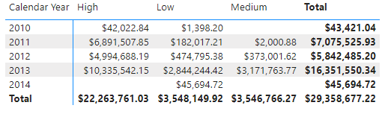

* 1. Insert a table  visual that displays “Total Sales Amount” against each “Calendar Year” and “Month Name”. The month name should be sorted chronologically [Jan … Dec]

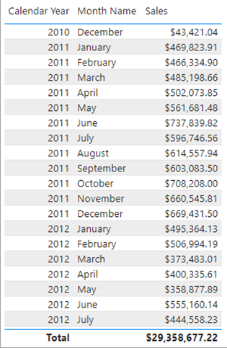

1. Insert a table  visual that displays “Total Sales Amount” and “Total Target Sales” against “Calendar Year”

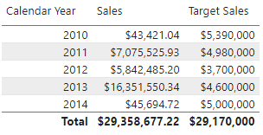

1. Insert a table  visual that displays “Total Sales Amount” and “Total Target Sales” against “Category Name”

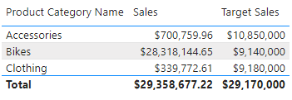

1. Insert a new page.
2. In “Page 2”
   1. Create “Profit” measure; it should subtract sum of sales amount from sum of product standard cost and divide by sum of product standard cost.
   2. Insert a card  visual. Display the profit.

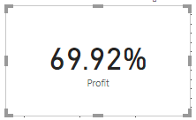

* 1. Modify the “Profit” measure to ignore “NA” product color

1. Insert a table  visual with sales amount and sales contribution % by product colors

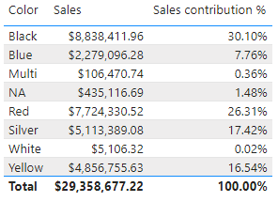

1. Insert a table  visual that displays count of high salaried customers who bought products in each year [High salaried customers: Year Income > $100,000]

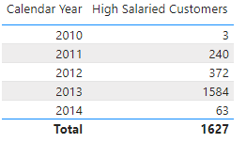

1. Insert a “Sales by time” page
2. “Sales by time” page
   1. Insert a matrix  visual that displays sales at the first date and last date of the time period

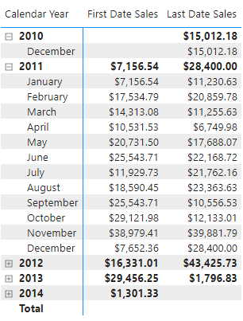

* 1. Insert a table  visual that displays the 'quarter running total' for sales

